CDA 3103 Computer Organization Homework

**Section I: Problems**

1. (10 points) Construct true tables for the following XOR and XNOR gates.

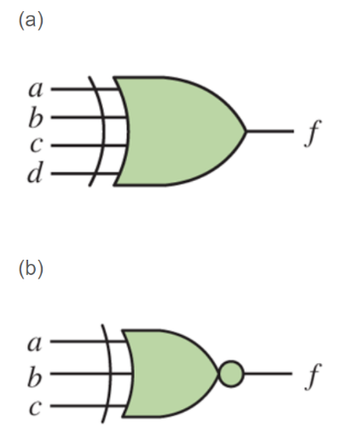

1. (10 Points) Write the Boolean expression in Canonical sum-of-products and Canonical product-of-sum forms for the following truth table without symbols and .

|  |  |  |  |
| --- | --- | --- | --- |
| *x* | *y* | *z* | *F* |
| 0 | 0 | 0 | 1 |
| 0 | 0 | 1 | 0 |
| 0 | 1 | 0 | 1 |
| 0 | 1 | 1 | 1 |
| 1 | 0 | 0 | 0 |
| 1 | 0 | 1 | 1 |
| 1 | 1 | 0 | 1 |
| 1 | 1 | 1 | 1 |

1. (20 points) find CSOP and CPOS forms for the following functions:
$F\left(a,b,c\right)= ab+a'c$

$F\left(A, B, C, D\right)=A\left(B^{'}+CD^{'}\right)+A'BC'D$

2. (10 points) Use DeMorgan’s theorem to complement the following expressions.
3. XY + AC’ + DE
4. X(Y + Z’(Q+R’))
5. (20 points) Use Boolean Identities to prove the following equations. **Show detailed steps to earn full credits and list Boolean identities applied for each step.**
6. ab + a’c + bc = ab + a’c
7. (a+b)(a’+c)(b+c) = (a + b)(a’ + c)
8. (30 Points) Use Boolean Identities to simplify the following Boolean functions. **Show detailed steps to earn full credits and list Boolean identities applied for each step.**

a)

b) 

**Section II: Submission Requirements**

The following requirements are for electronic submission via Canvas.

* Your solutions must be in a single file with a file name yourname-module3-assignment-1.
* Upload the file by following the link where you download the homework description on Canvas.
* If scanned from hand-written copies, then the writing must be legible, or loss of credits may occur.
* Only submissions via the link on Canvas where this description is downloaded are graded. Submissions to any other locations on Canvas will be ignored.